# **How to Take a Screenshot to Evidence Completion**

**PLEASE MAKE SURE YOUR SCREENSHOT INCLUDES THE NAME OF THE COURSE AND DATE COMPLETED. IF NEED BE TYPE THIS INFORMATION INTO THE WORD DOCUMENT**

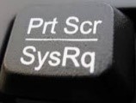To take a screenshot (copy of what is on your screen) on a laptop or PC: 

* Press the **prt scr** button on your keyboard

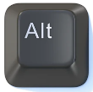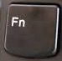  
Depending on your keyboard, you may need to also hold down the   
Alt or Fn key at the same time.  
 

* Open MS Word, new document
* 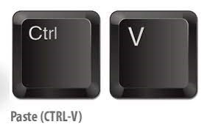Click anywhere in the blank document
* Graphical user interface

  Description automatically generated with medium confidenceA picture containing text, monitor, microwave, electronics

  Description automatically generatedPaste the screenshot by pressing (**Ctrl + V**) at the same time
* Save the document by pressing (**Ctrl + S**) at the same time

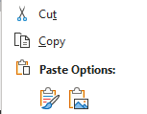

Alternatively, you can also click the mouse right hand button to get copy

and paste options

If you have completed the course on a tablet or smartphone, then usually, to take a screenshot you press the ‘home’ button and ‘power’ button at the same time, holding for a second before releasing. In some cases, it may be ‘volume’ and ‘power’ buttons.

This should add the screenshot to your ‘picture’ folder.

