**Accessing Dysphagia e-learning on Nutricia website**

Click on the link below, or copy and paste this into your internet browser:

<https://www.nutricia.co.uk/patients-carers.html>

On opening, you should select the option ‘I confirm I am a Healthcare Professional’ as this includes anyone in the Health & Social Care Partnership

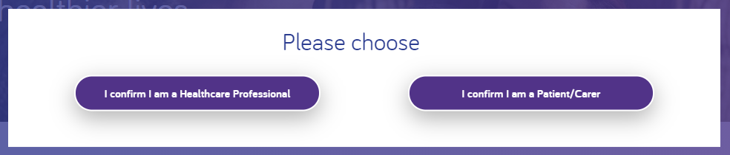

Once selected, you need to scroll down the page to find the section for e-learning. Click on Find out more

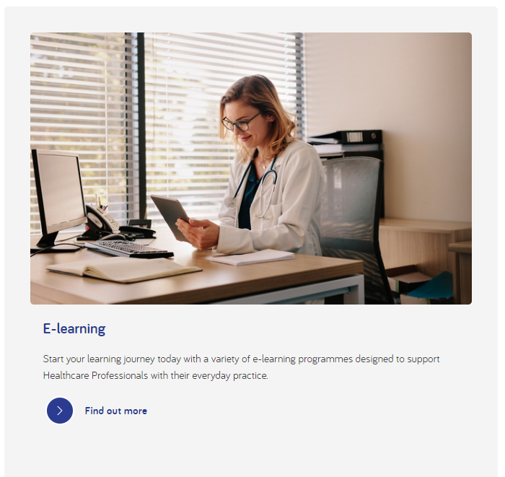

You will then have to create an account. This is free. Click on the button to Register

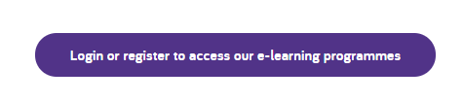

Complete all the information required, remember to tick the box for I am a Healthcare Professional

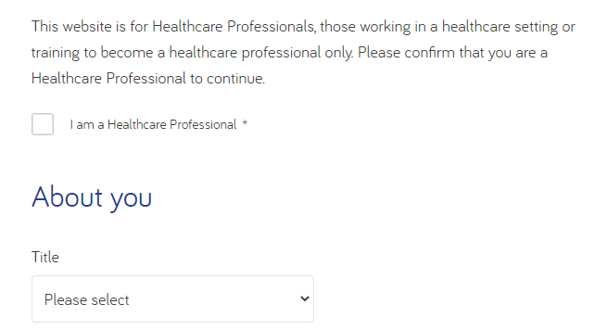

You should then get an email which you need to open and click on the link to confirm your email address and login. Please make sure you remember your username (your email address) and password. Once logged in, click ‘Find out more’ on the Discover our e-learning programmes block.

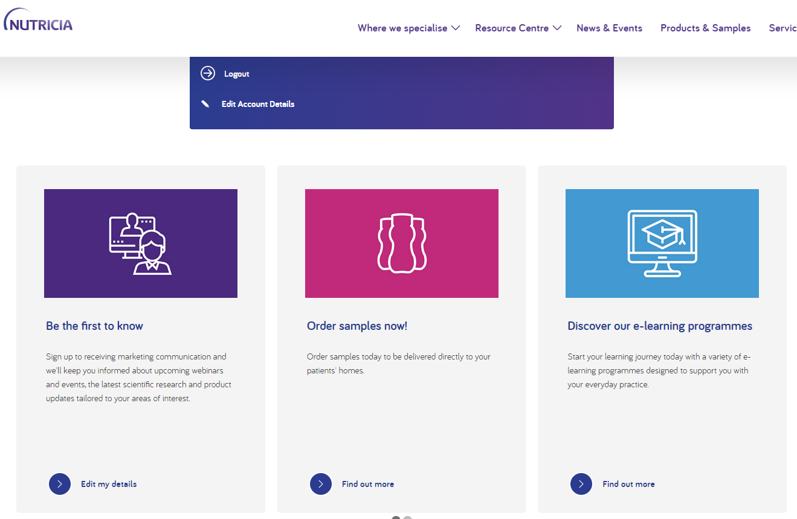

If the opening page is not showing the Catalog already, click on the Explore Catalog at the bottom of Recommended Learning

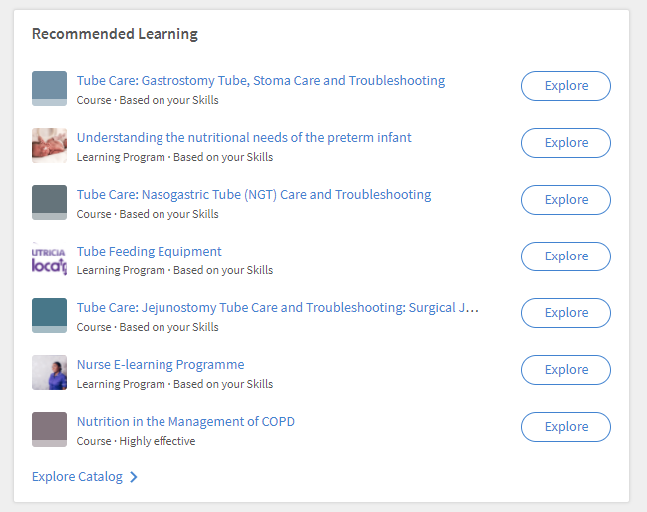

Once in the catalog, click on ‘Management of Dysphagia’

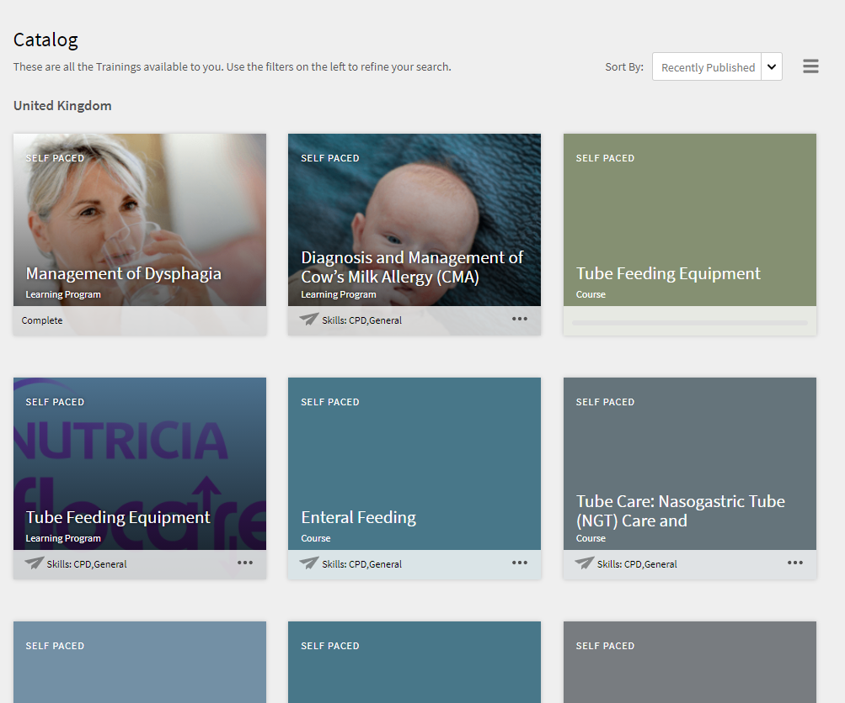

As I’ve already completed this, I have the option to Revisit, but you should have an option to click on the individual modules and complete each one.

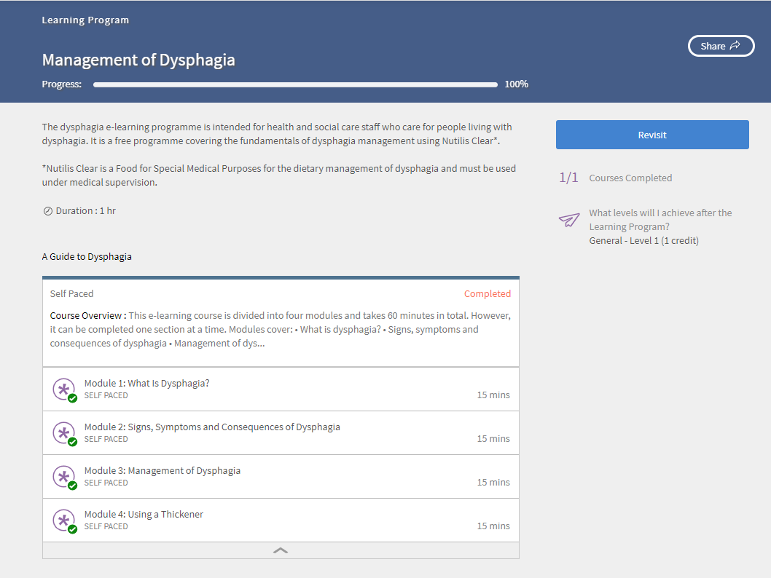

Once you have completed all 4 modules, you will receive an email confirming your completion. Please save this email as your evidence or take a screenshot of the page shown above which confirms all modules are completed. Add in the date when you save the screenshot to remind you when this was completed. Check your spam/junk folder if this email does not arrive.

